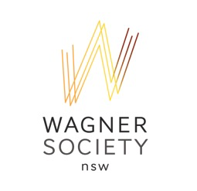
www.wagner.org.au

Application form for requesting support from Wagner Society for singers and repetiteurs

The Society supports the training of young Wagnerian or potential Wagnerian performers from NSW. Support may be provided for German courses, travel and/or accommodation for workshops, auditions, competitions, specialised coaching etc as relevant to Wagner for singers or repetiteurs.

Please email the completed form to: webmaster@wagner.org.au

Name

Address

NSW based or origins

Mobile

Email

What you do musically, eg tenor, repetiteur?

Musical or other relevant qualifications or experience?

Any grants/awards/scholarships?

Project for which support is requested?

How does this project fit with the aims and objectives of the Society, namely the promotion of the music of Richard Wagner, his contemporaries and followers and encouraging a wider understanding of their work?

Specific amount requested?
$

Approximate $ breakdown, eg $ German lessons, $ coaching, $ accommodation, etc?

Any matching grant?

Date by which you need a decision

on support from the Society?

NOTE: Applications are accepted at any time throughout the year. The Wagner Society Committee meets six times a year and considers funding submissions at these meetings. Therefore, it is strongly recommended that applications for support be submitted at least three months before the beginning of the project for which support is being sought.

How will you acknowledge the Society’s support?

Please attach References (at least 2) - such as from a teacher or coach

It would also be helpful if you are also able to provide:

- Sound clips/video clips (which we might request to publish)

- CV/biography

- Repertoire list

